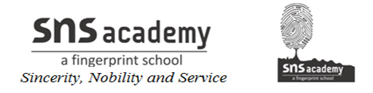

**MONTHLY TEST- DECEMBER**

**MATHEMATICS**

**Class: V Max Marks: 30**

**Date: 07.12.19 Time: 1 hr**

**I. Fill in the blanks: (4 × 1= 4)**

1) A __________ is an instrument used to measure angles.

2) A __________ has no length, breadth or height.

3) The number for 1 + 0.2 is ________.

4) The place value of 6 in the number 21.36 is ______.

**II. Answer the following: (3 × 2= 6)**

5 ) Write the type of angle whose measures are given below

(a) 135O (b) 25O

6) Write the missing decimals.

(a) 2.3 2.4 _____ _______

(b) 8.71 8.72 ______ _______

7) Write the equivalent decimals

(a) 7.23 , 3.2 , 125.625

(b) 30.4 , 42.61 , 100.123

**III. Answer the following: (4 × 3= 12)**

8) Write the decimal number for

(a) five and two hundred sixty thousandths

(b) sixteen and two thousandths

(c) twelve and two tenths

9) Write a decimal number for the following

(a) 4 in the tens place, 2 in the ones place, 6 in the tenths place

(b) 40 + 1 + 

10) (a) Add: 6.42 + 6.041 + 3.1

(b) Subtract: 16.423 – 7.23

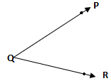11) Look at the figure and name.

the angle ________

arms ________

vertex ______

**IV. Answer the following: (2 × 4= 8)**

12) Arrange

(a) 0.125, 1.2, 1.3, 1.32 in descending order

(b) 0.64, 0.13, 0.06, 0.75 in ascending order

13) Use a protractor to draw the following angles.

(a)  (b) 